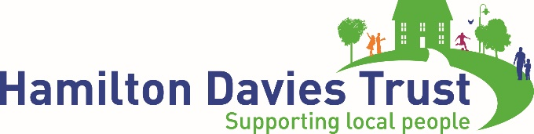

For immediate release:

Salford charity announces major sponsorship deal for Irlam music festival

Irlam-based charity the Hamilton Davies Trust (HDT) has continued its track record of backing local community and cultural events by announcing that it will be sponsoring Irlam Live 2017.

HDT has provided £2,000 of funding for the festival, which this year runs from Friday 2 June to Sunday 4 June at Prince’s Park, Irlam, and includes headline acts Jason Donovan, Alexander O’Neal and Odyssey.

It is the first time the charity has backed Irlam Live, which was founded in 2015 by three local men and attracts crowds of up to 8,000 people to see world-class artists supported by local talent.

HDT has funded a wide range of community arts and cultural events in the Irlam, Cadishead and Rixton-with-Glazebrook areas of Salford, such as, most recently, a number of major pieces of urban artwork celebrating local history, a new base for Cadishead Band and sponsoring local musician Jess Kemp’s first European tour.

HDT founder Neil McArthur said: “As well as being one of the most exciting cultural and musical dates on the local calendar, Irlam Live has a fantastic community spirit. We are proud to be able to support our local festival and hope our backing helps Irlam Live 2017 achieve even greater success this year.”

Darren Goulden, who founded the event along with Phil Brookes and Sam Butterworth, said: “

Irlam Live 2017 consists of ‘Legends Friday’, ‘Soulfest Saturday’, and ‘Retro Sunday’ and finishes at 9pm each night.

Toyah Wilcox is set to perform and Bob Marley’s Wailers will also be flying in from Jamaica. Other highlights include Jess Kemp, The New York Brass Band, which has previously performed at Parklife, and award-winning theatre company Manchester Musical Youth.

For media information, images and interviews with Mr McArthur and Mr Portillo, contact:
Andrew Spinoza (07711 718114) and Jason Grimsley at SKV Communications 0161 838 7770.

Editor’s Notes
HDT was founded by Neil and Anne McArthur in 2004 with the aim of supporting the local communities of Irlam and Cadishead in Salford, with additional support given to Rixton-with-Glazebrook (Warrington). Neil is a founder of the Talk Talk group.

With a strong leadership with local roots and working closely with local people, it has invested £6m of private funds to date into the area.

This includes distributing over 450 grants to local organisations and projects and, with partners, funding a number of major, high-quality infrastructure projects such as the building of a new sixth form college, the refurbishment of the local leisure centre and the refurbishment of Irlam Railway station.

A key partner is NC Developments Ltd (NCD), a property company owned by Neil McArthur which delivers building and public realm projects part- or full funded by HDT to improve life in Irlam and Cadishead.

According to a 2014 report by Commission for the New Economy, the work of the HDT and partners is supporting significant social and economic improvements in the area, and local people identify the charity as the key driver of regeneration.

http://neweconomymanchester.com/media/1468/irlam-cadishead-report.pdf

